**Matplotlib**

**What is Matplotlib?**

* Matplotlib is a low level graph plotting library in python that serves as a visualization utility.
* Matplotlib was created by John D. Hunter.
* Matplotlib is open source and we can use it freely.
* Matplotlib is mostly written in python, a few segments are written in C, Objective-C and Javascript for Platform compatibility.

**Installing Matplotlib**

If not installed, use:

**pip install matplotlib**

**Import Matplotlib**

Once Matplotlib is installed, import it in your applications by adding the import *module* statement:

**import matplotlib**

Now Matplotlib is imported and ready to use:

**Checking Matplotlib Version**

The version string is stored under __version__ attribute.

**Example**

import matplotlib  
print(matplotlib.__version__)

**Importing Pyplot**

import matplotlib.pyplot as plt

**Pyplot**

pyplot is a **module in Matplotlib** used for **creating visualizations** like line plots, bar charts, histograms, and scatter plots. It provides an **interface similar to MATLAB** and makes it easy to plot and customize graphs.

* Plotting x and y points
* The plot() function is used to draw points (markers) in a diagram.
* By default, the plot() function draws a line from point to point.
* The function takes parameters for specifying points in the diagram.
* Parameter 1 is an array containing the points on the x-axis.
* Parameter 2 is an array containing the points on the y-axis.

**Markers**

You can use the keyword argument marker to emphasize each point with a specified marker:

**Marker Reference**

You can choose any of these markers:

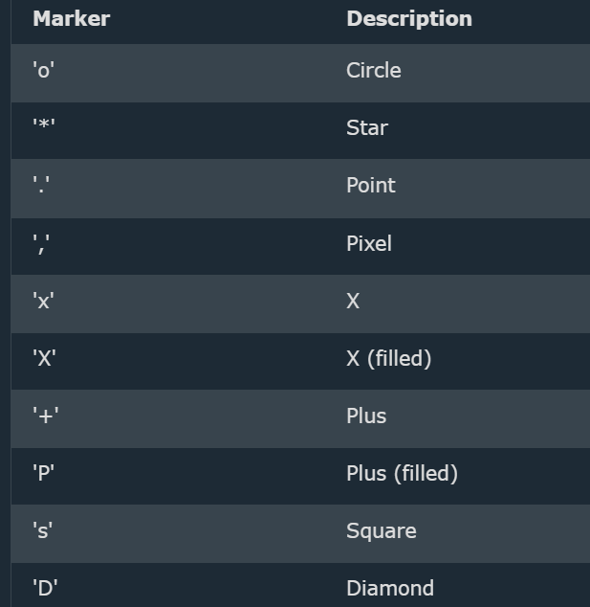 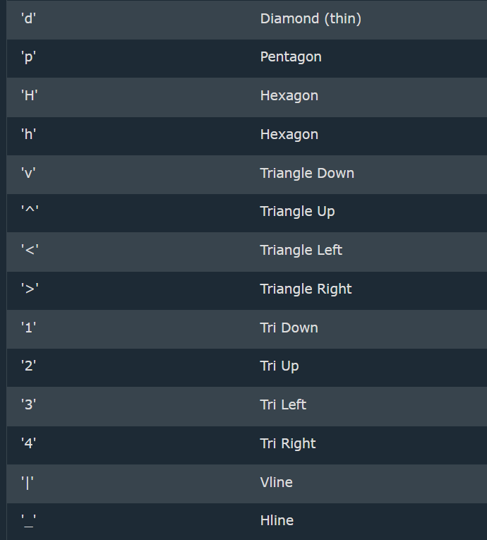

**Line Reference**

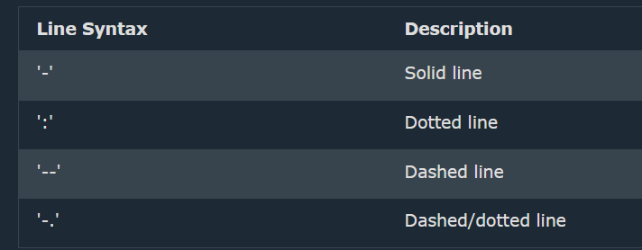

**Color Reference**

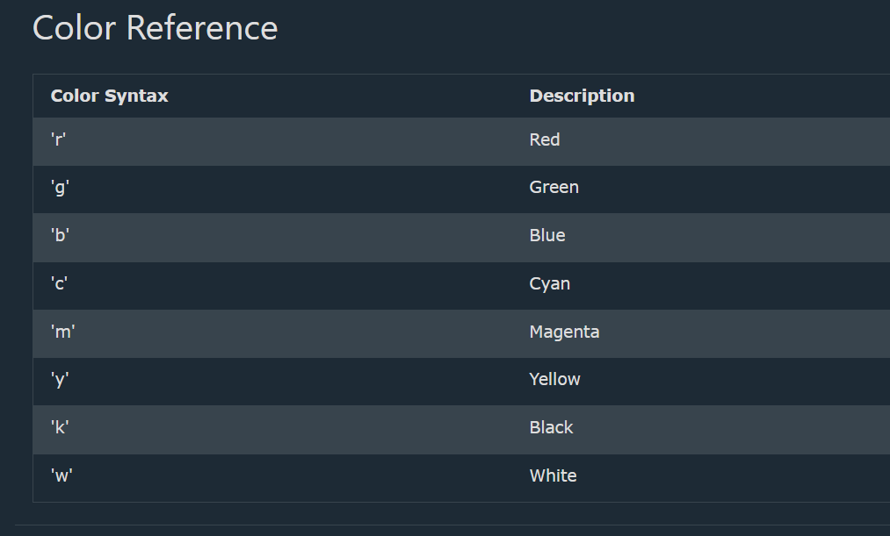

**Marker Size**

You can use the keyword argument **markersize** or the shorter version, **ms** to **set the size of the markers:**

**Example**

Set the size of the markers to 20:

import matplotlib.pyplot as plt  
import numpy as np  
  
ypoints = np.array([3, 8, 1, 10])  
plt.plot(ypoints, marker = 'o', ms = 20)  
plt.show()

**Marker Color**

You can use the keyword argument **markeredgecolor** or the shorter **mec** to **set the color of the *edge* of the markers**:

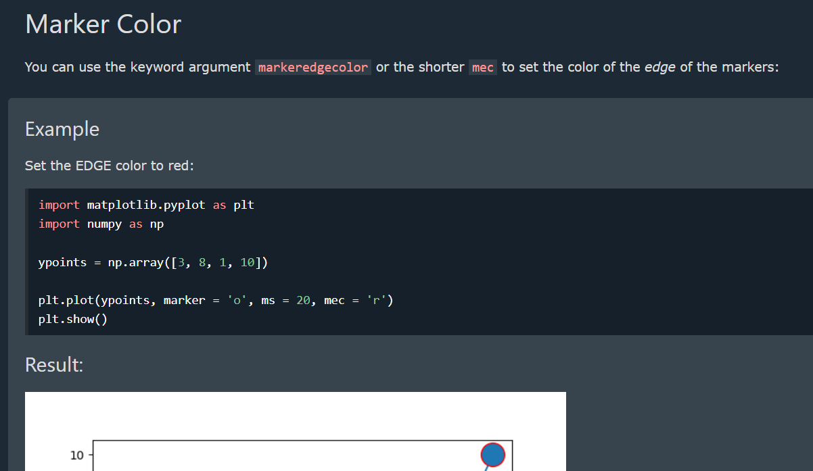

You can use the keyword argument **markerfacecolor** or the shorter **mfc** to **set the color inside the edge of the markers**:

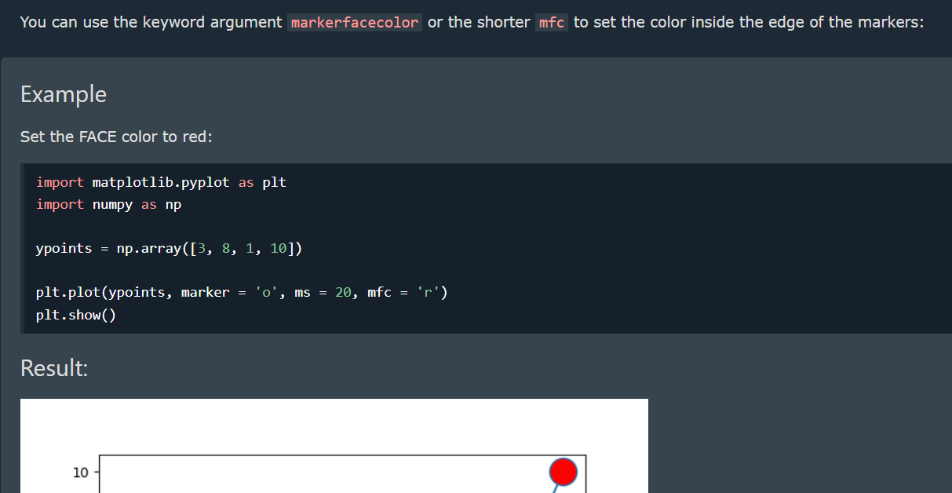

**Line Color**

You can use the keyword argument color or the shorter **c** to **set the color of the line**:

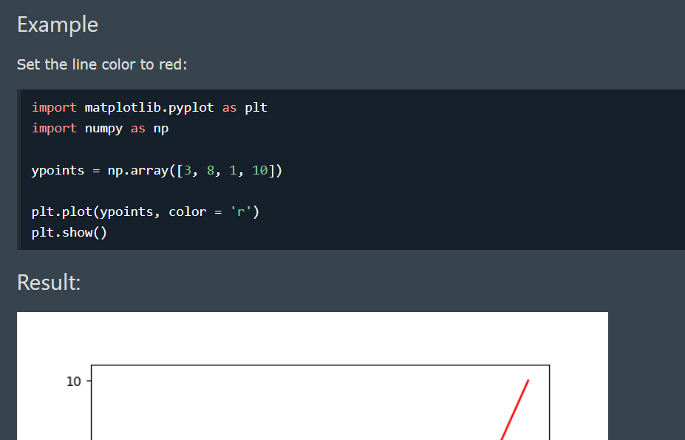

**Line Width**

You can use the keyword argument linewidth or the shorter **lw** to change the width of the line.

The value is a floating number, in points:

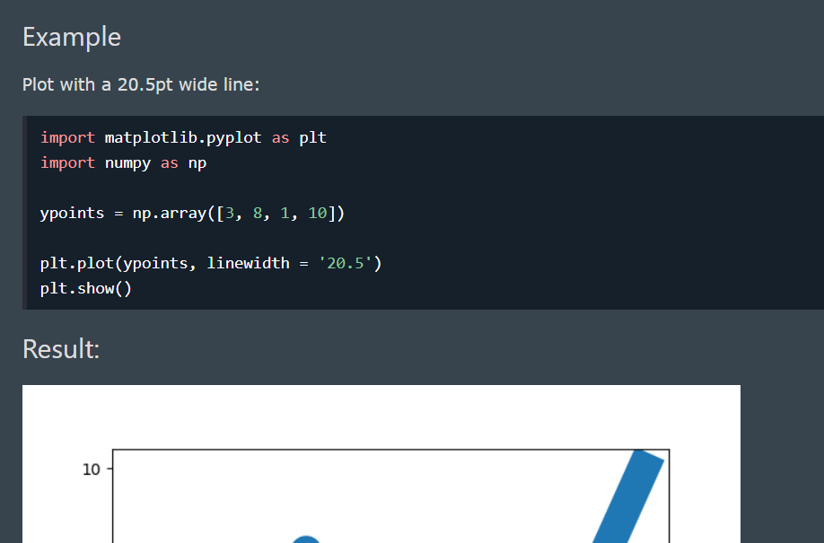

**Multiple Lines**

You can plot as many lines as you like by simply adding more **plt.plot()** functions:

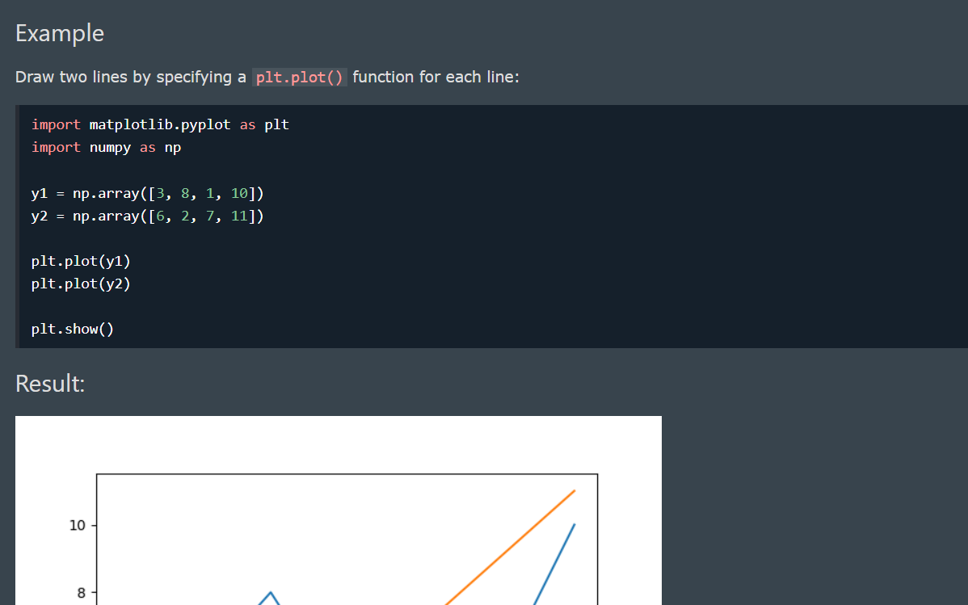

**Basic Structure of Pyplot**

import matplotlib.pyplot as plt

x = [1, 2, 3, 4, 5]

y = [10, 15, 8, 20, 18]

plt.plot(x, y) # Create a line plot

plt.show() # Display the plot

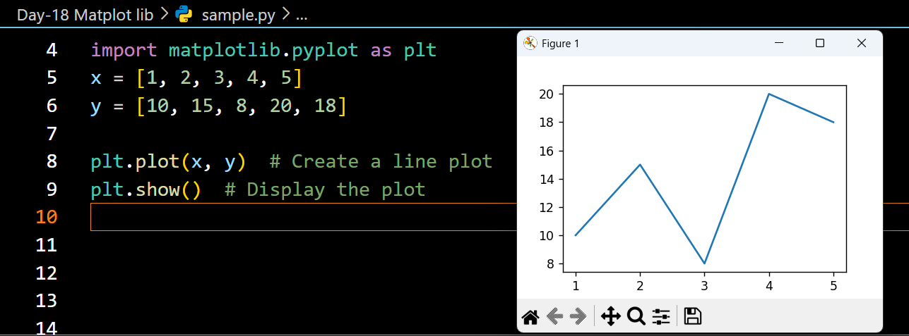

**Adding Labels & Title**

* With Pyplot, you can use the **xlabel() and ylabel() functions to set a label for the x- and y-axis**.
* With Pyplot, you can use the **title()** function to set a title for the plot.
* You can use the loc parameter in **title()** to **position the title**. Legal values are: 'left', 'right', and 'center'. Default value is 'center'.

plt.plot(x, y, marker="o", linestyle="--", color="b")

plt.xlabel("X-axis Label") # Label for X-axis

plt.ylabel("Y-axis Label") # Label for Y-axis

plt.title("Line Plot Example") # Title of the Graph

plt.show()

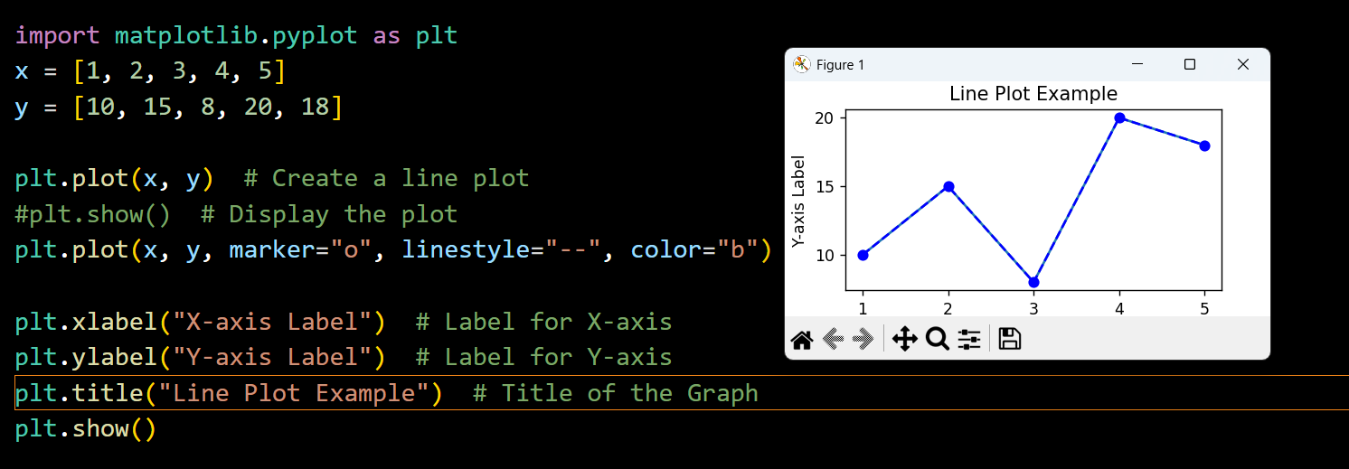

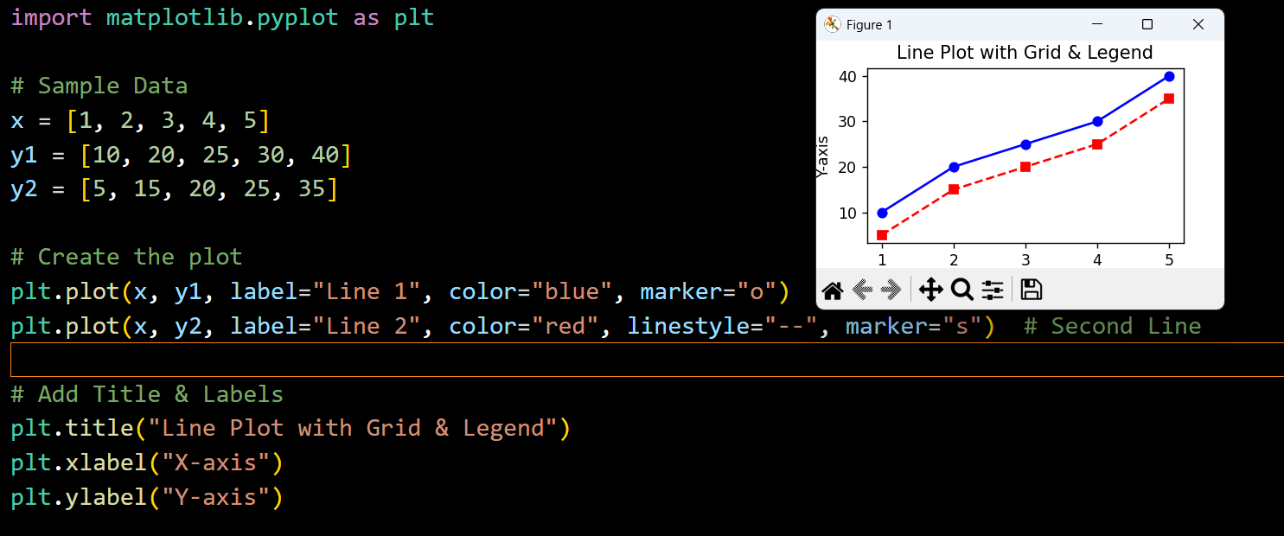

**Adding a Grid & Legend**

* In **Matplotlib**, you can add a **grid** using **plt.grid(True)** and a **legend** using **plt.legend()**
* You can use the axis parameter in the **grid()** function to specify which grid lines to display.
* Legal values are: 'x', 'y', and 'both'. Default value is 'both'.
* You can also set the line properties of the grid, like this: grid(color = '*color*', linestyle = '*linestyle*', linewidth = *number*).

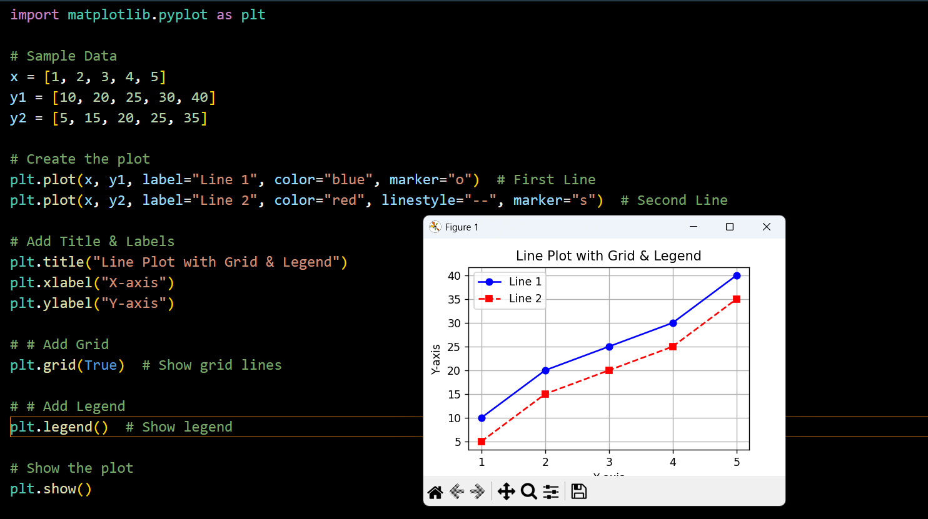

**Display Multiple Plots**

With the **subplot()** function you can draw multiple plots in one figure:

**The subplot() Function**

* The **subplot()** function takes three arguments that describes the layout of the figure.
* The layout is organized in rows and columns, which are represented by the *first*and *second*argument.
* The third argument represents the index of the current plot.

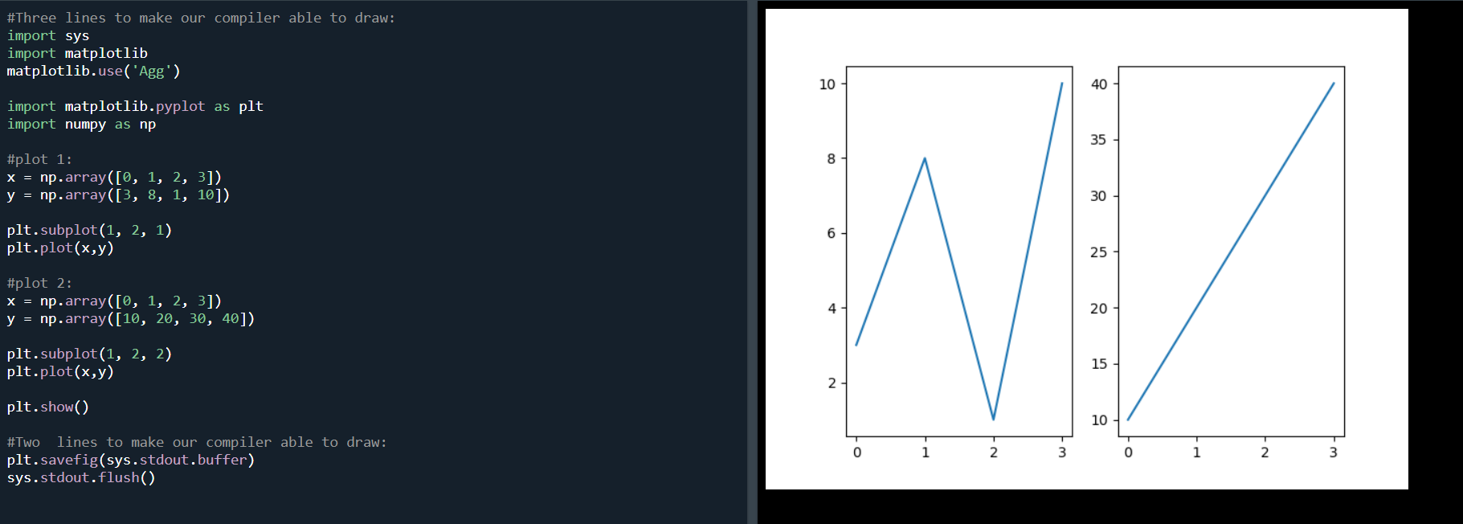

**Different Plot Types**

**Line Plot**

plt.plot(x, y, marker="o", linestyle="-", color="blue")

plt.show()

**Bar Chart**

* With Pyplot, you can use the **bar() function to draw bar graphs**
* If you want the bars to be **displayed horizontally** instead of vertically, use the **barh()** function
* The **bar() and barh()** take the keyword argument color to set the color of the bars
* plt.bar(x, y, color = "red")
* The **bar()** takes the keyword argument **width** to **set the width of the bars**
* The **barh()** takes the keyword argument **height** to **set the height of the bars**

categories = ["A", "B", "C", "D"]

values = [5, 7, 3, 8]

plt.bar(categories, values, color="green")

plt.show()

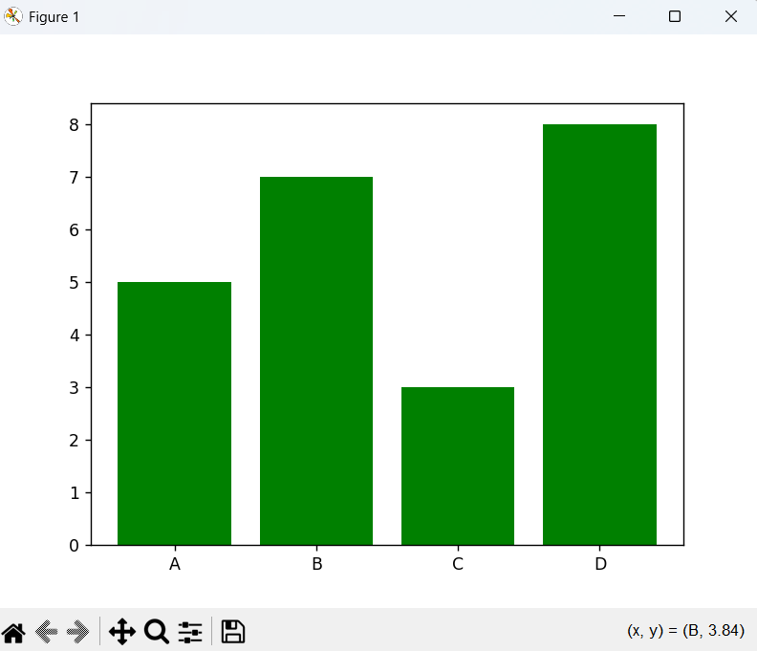

**Scatter Plot**

* With Pyplot, you can use the **scatter()** function to draw a scatter plot.
* The **scatter()** function plots one dot for each observation. It needs two arrays of the same length, one for the values of the x-axis, and one for values on the y-axis
* You can even set a specific **color for each dot** by using an array of colors as value for the **c argument**
* You can change the **size of the dots** with the **s** argument.
* You can **adjust the transparency** of the dots with the **alpha** argument.

plt.scatter(categories, values, color="red", marker="x")

plt.show()

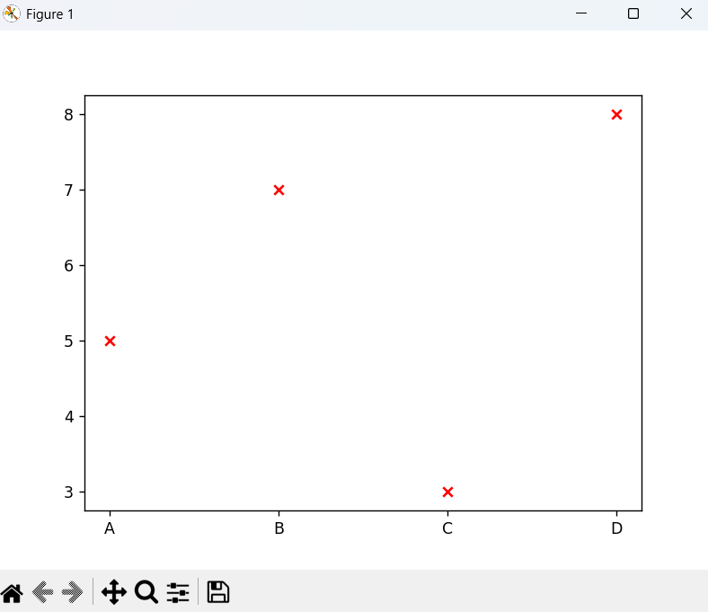

**Compare Plots**

In the example above, there seems to be a relationship between speed and age, but what if we plot the observations from another day as well? Will the scatter plot tell us something else?

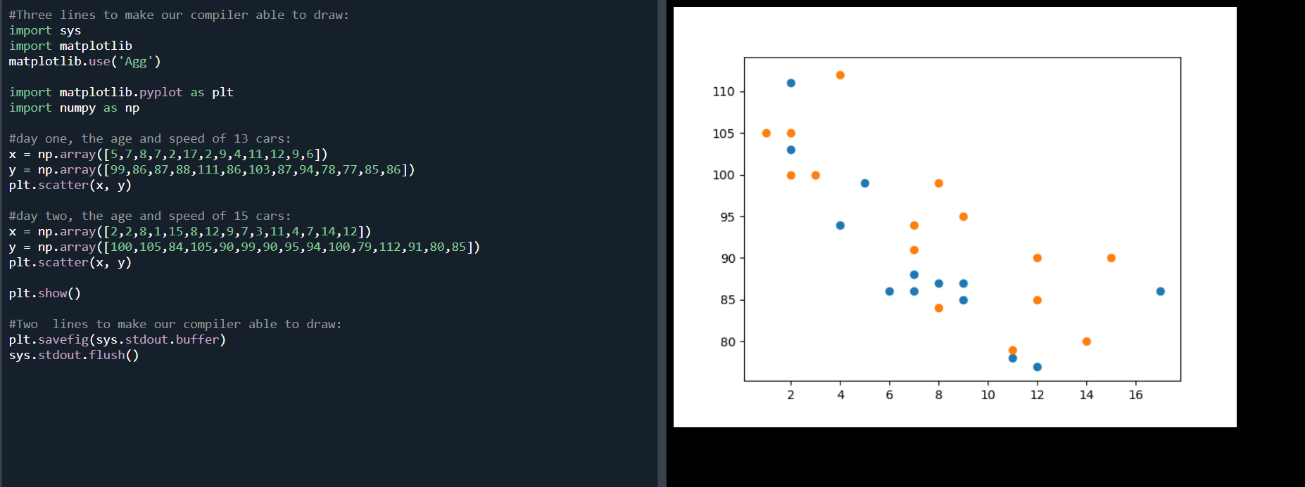

**Histogram**

* A histogram is a graph showing *frequency* distributions.
* It is a graph showing the number of observations within each given interval.
* The **hist()** function will read the array and produce a histogram

import numpy as np

data = np.random.randn(1000) # Random data

plt.hist(data, bins=20, color="purple", edgecolor="black")

plt.show()

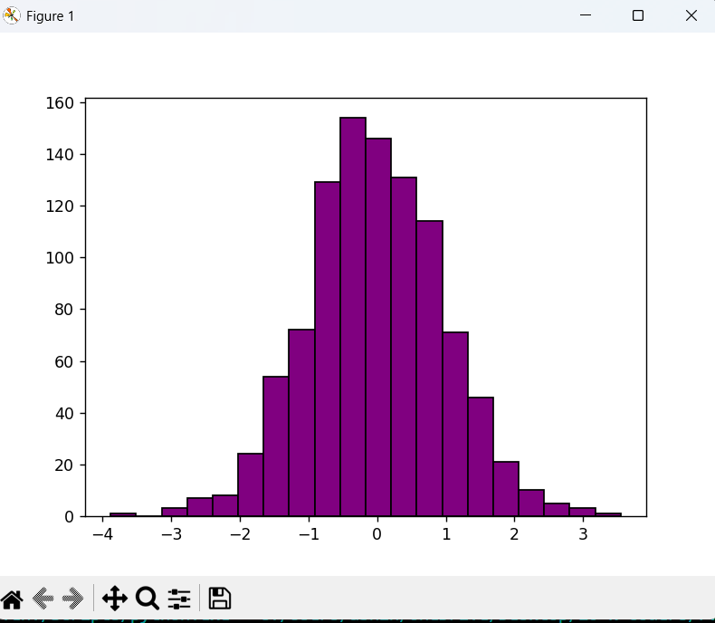

**Pie Chart**

* With Pyplot, you can use the **pie()** function to draw pie charts
* Add labels to the pie chart with the **labels** parameter.
* The labels parameter must be an array with one label for each wedge
* Maybe you want one of the wedges to stand out? The explode parameter allows you to do that.
* The **explode parameter**, if specified, and not None, must be an array with one value for each wedge.
* **Add a shadow** to the pie chart by setting the **shadows** parameter to True
* To **add a list of explanation for each wedge**, use the **legend()** function
* To **add a header to the legend**, add the **title parameter to the legend function**.

labels = ["Python", "Java", "C++", "JavaScript"]

sizes = [40, 25, 20, 15]

plt.pie(sizes, labels=labels, autopct="%1.1f%%", colors=["blue", "red", "green", "yellow"])

plt.title("Pie Chart Example")

plt.show()

